**Week-04-Decision Making and Looping - while, do…while and for**

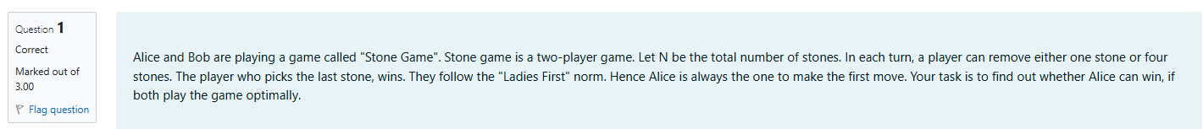

SOURCE CODE

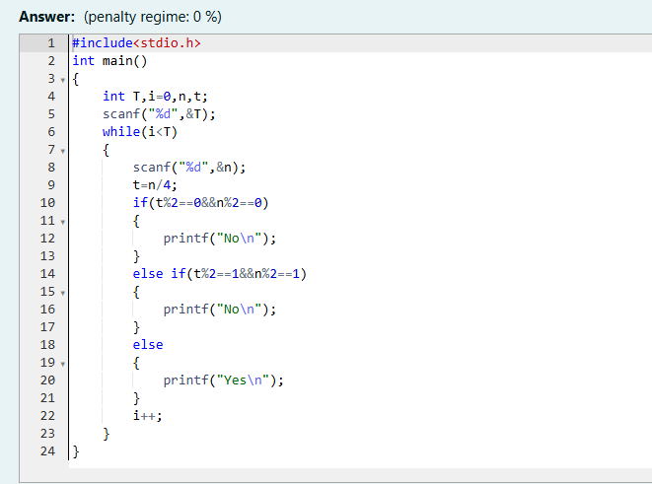

Result

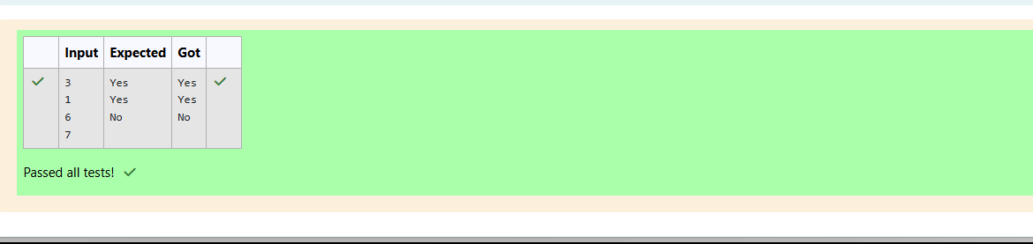

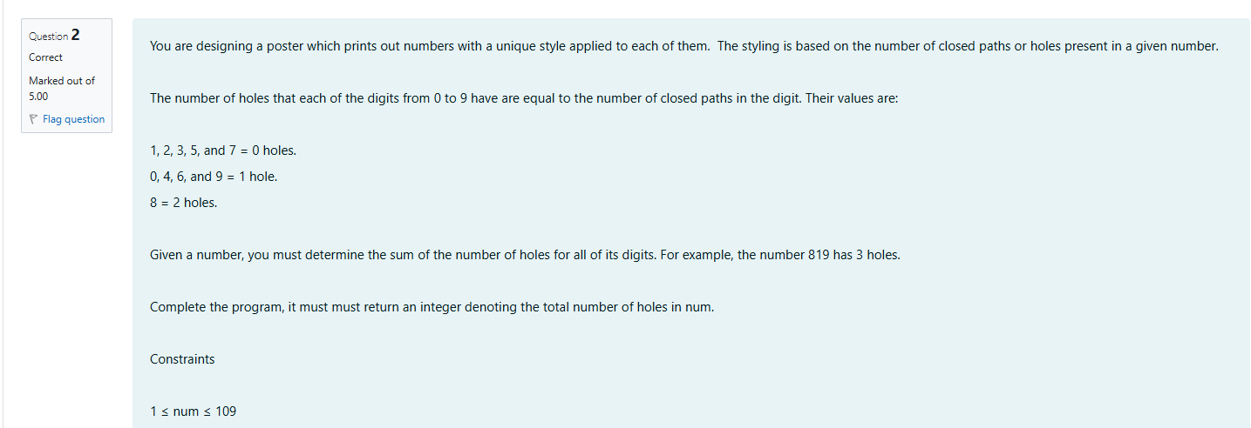

SOURCE CODE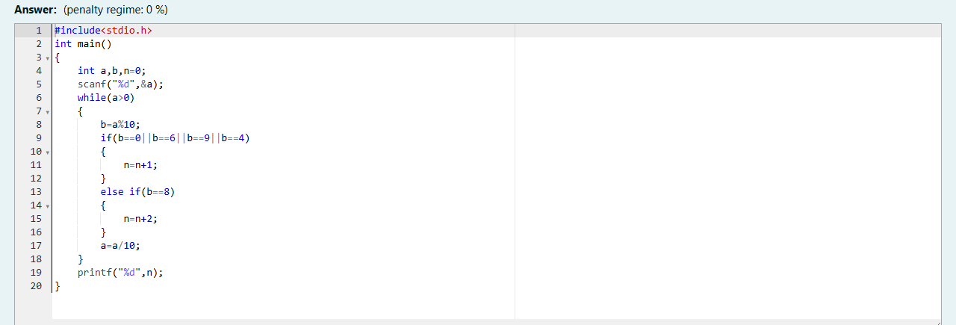

Result

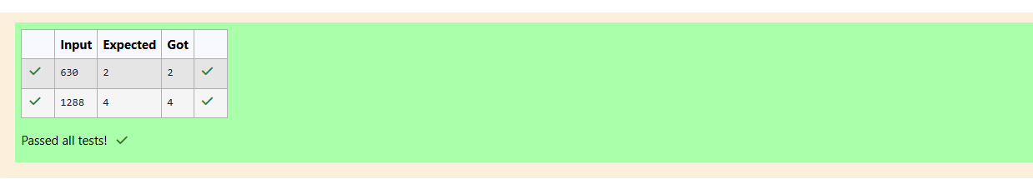

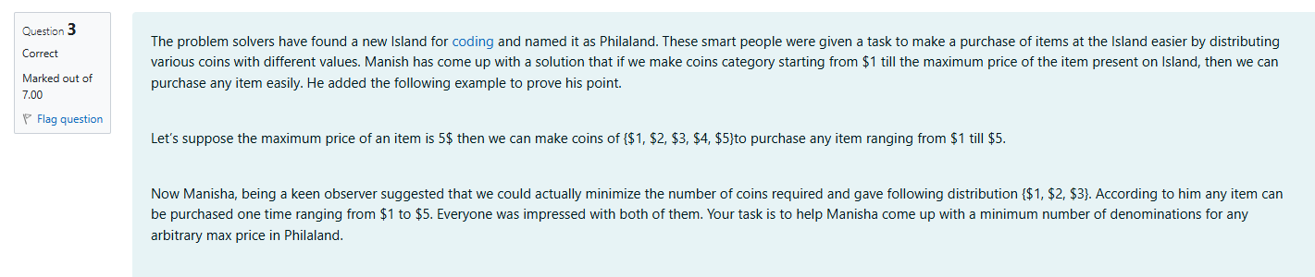

SOURCE CODE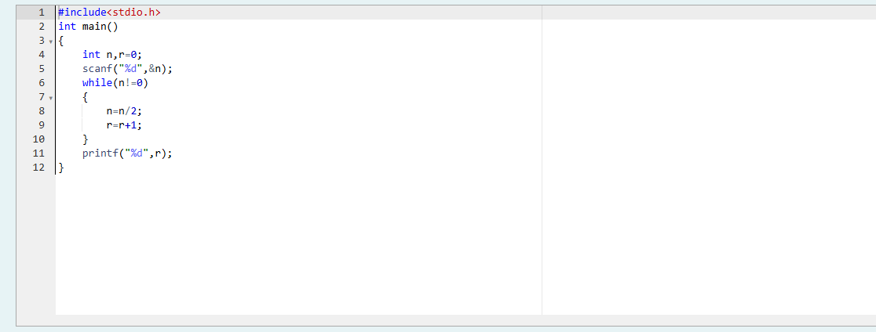

Result

